

Operator Manual

For

Reverse Osmose System



Contents :

1. Safety Informations

1.1 Warning labels……………………………………………………………...2
1.2 Safety instructions………………………………………………………….3

2. Introduction to the system

2.1 Introduction……………………………………………………………….....4
2.2 Overview of the system…………………………………………………….4
2.3 General description…………………………………………………………5
2.4 Description of the control unit ………………………………………….....6

3. Technical Specifications 7

4. Installing Osmoser

4.1 Installations Conditions……………………………………………………. 8
4.2 Connections………………………………………………………………… 8
4.3 Installation of the reverse osmosis membrane…………………………. 9

5. System start up 10

6. Maintenance and service

6.1 Flow measurement procedure……………………………………………12

6.2 Conductivity measurement procedure ………………………………….13
6.3 Consumables replacement procedure…………………………………..15
6.4 Controls and maintenance………………………………………………..20
6.5 Troubleshooting……………………………………………………………21

7. Consumable and spare parts

7.1 Consumables………………………………………………………………23
7.2 Spare parts…………………………………………………………………24

8. Flow path diagram……………………………………………………………………26

9. Accessories 27

The user is requested to read the safety information in the manual before installing the analyzer..

- Safety Informations

1.1 Warning labels

Before reading the manual, please get familiarized with the following icons used in this manual.

→ Electric Shock

→ Warnings and Caution

1.2 Safety instructions

To ensure the product SECURITY and RELIABILITY, all repairing must be realized with spare parts available with our after-sales service.
If the power cable is damaged, it must be replaced by a certified new power cable.

Unplug the osmoser by the power plug. Don’t pull on the wire.

Before all intervention on the osmoser, be vigilant to turn off the switch and unplug the power plug.

Use exclusively tap water to supply the osmoser.
- MAXIMUM NETWORK PRESSURE = 6 BARS
- Maximum supply water temperature = 38 °C.

This osmoser model functions only on mains tension 230 volts ~ / 50 Hz.
Don’t connect too much instruments on the same plug in order to not risk fire or electric shock.

2. Introduction to the system
2.1 Introduction
The DiaSys Osmoser « O MINI » is a purified water production system allying two water treatment leading-edge technologies:

- The REVERSE OSMOSIS, which is currently the most effective and elaborated - membranous separation process,

- The demineralization principle by IONS EXCHANGERS RESINS.

These two associated technologies allow getting water with excellent quality regarding physical composition, chemical composition (mineral and organic) and micro organic population.

2.2 Overview of the system (front view)

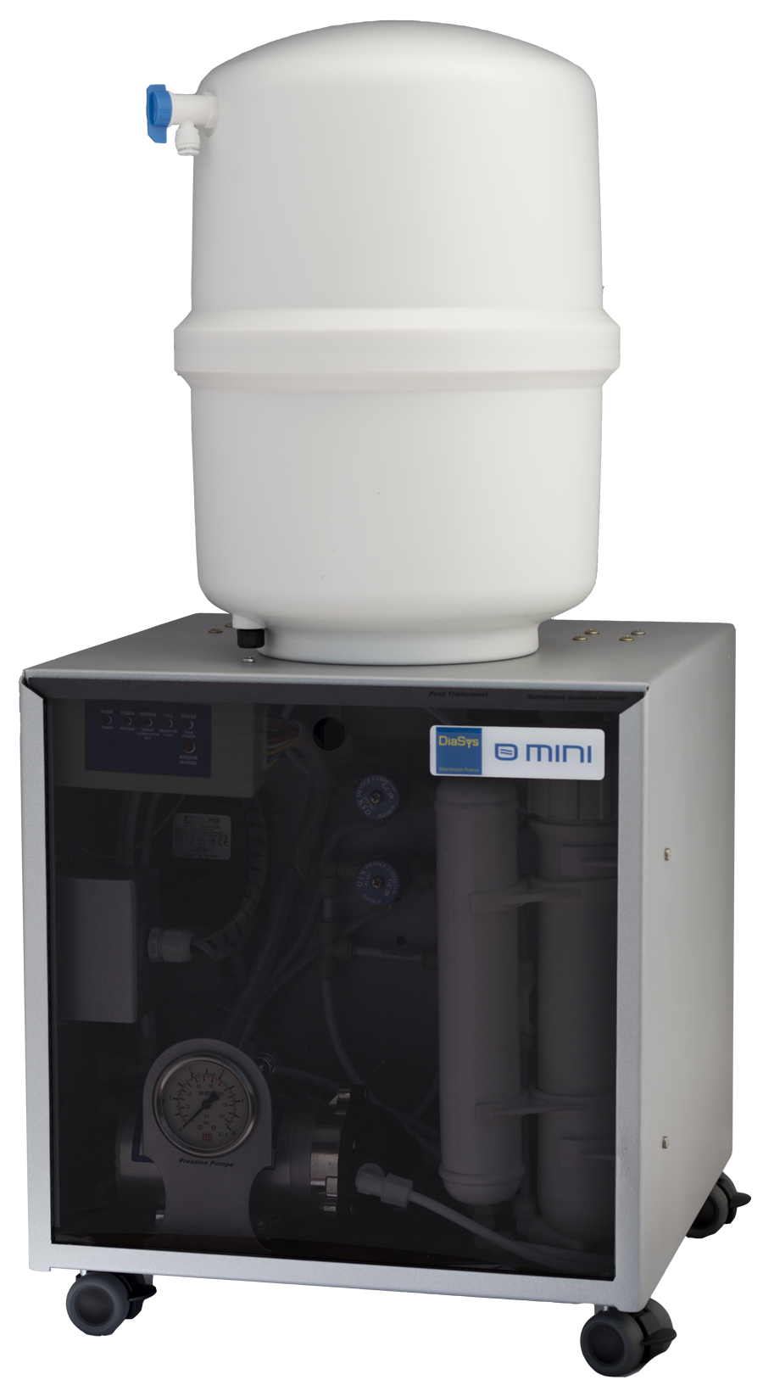
Storage tank

Electronic
Reverse osmosis membrane
control case

Booster pump

Post treatment

2.2 Overview of the system (back view)
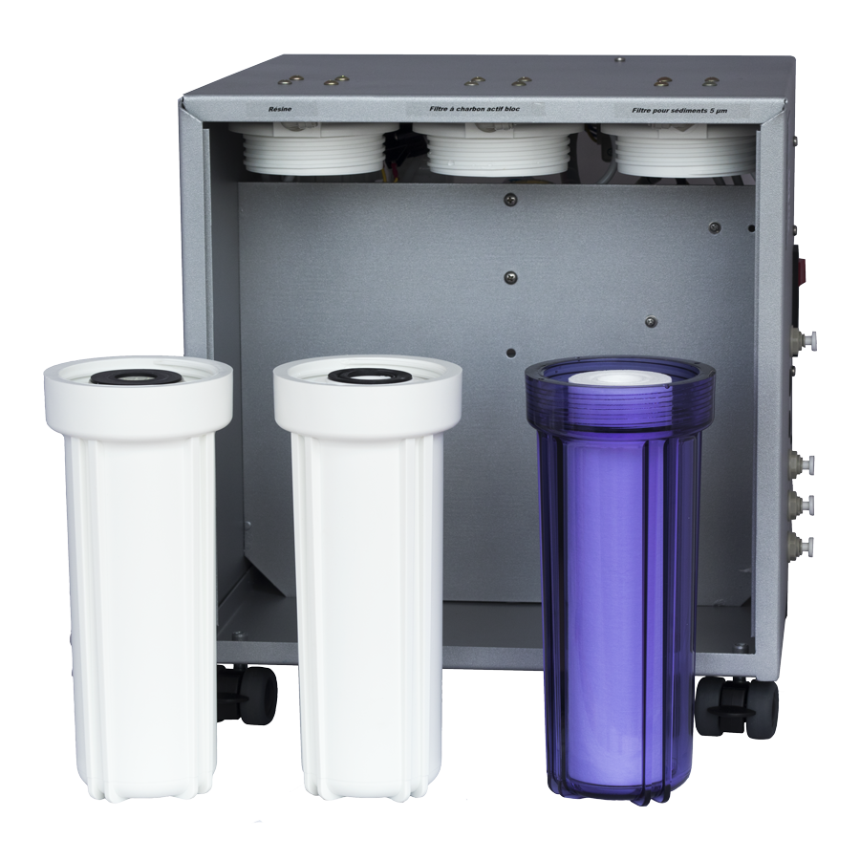

Filter for
sediments 5 μm
Ions
exchangers
resins
Block active charcoal fitler

2.3 General description

The "o mini" osmosis system is a water treatment system that includes a series of prefiltration cartridges for the network water: Sediment filter 5 μm + Block carbon filter.

Once this water is treated, it is then injected via a booster pump into the reverse osmosis membrane.

The water obtained is thus discharged of 90% of its organic and inorganic compounds.

In order to complete the complete treatment, this water is then injected into an ion exchange resin container and then filtered by a 5 μm post-treatment filter.

The electromechanical assembly is managed by an electronic control unit.

2.4 Description of the control unit

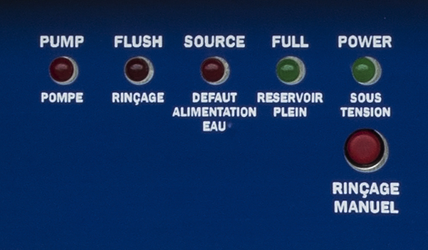
Terms meaning :
PUMP : PUMP
FLUSH : RINSING
SOURCE : WATER SUPPLY
FULL : FULL TANK
POWER : UNDER TENSION
MANUAL : MANUAL RINSING

PUMP indicator turned on Pump functioning: means the osmoser is either producing or rinsing.

Flush indicator turned on The osmoser makes an automatic rinsing cycle of the reverse osmosis membrane; a rinsing (of around 2 min) happens:
- following to the instrument starting,
- following a frequency of around 6 hours,
- following a pressure on the Manual button.

SOURCE indicator turned on Lack of flow or pressure on water supply.

Full indicator turned on Full storage tank.

POWER indicator turned on Osmoser under tension; this indicator is switched on permanently, whatever the other indicators states are.

Manual push button Press this button makes starting a forced rinsing of the membrane during 2 min.

The different situations:

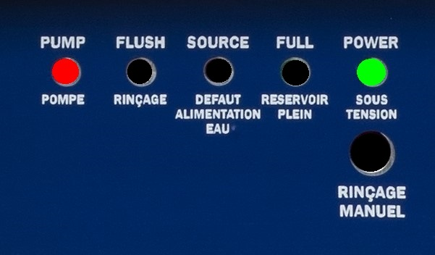
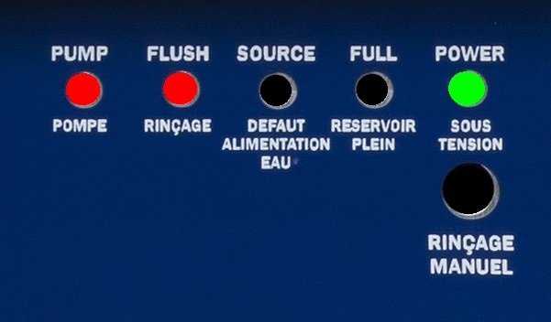

Osmoser producing

Rinsing cycle

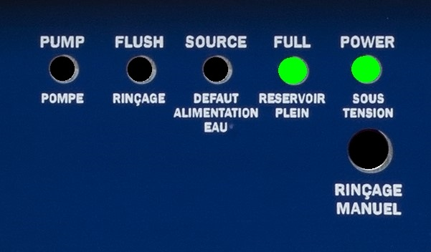
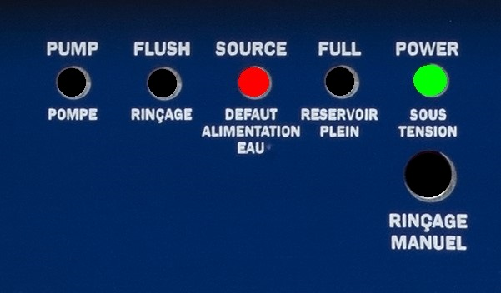

Water supply default

Water storage tank full

3. Technicals specifications

Power tension 230 volts ~ / 50 Hz.

Production flow at 25 ° C 15 liters / hour

Production flow at 10 ° C 9 liters / hour

Resin type Resin with mixed beds

Resins volume 0.75 liters

Maximum supply water temperature 38 °C

Maximum hardness without protection 40 °f of TH

Admissible pH 3 to 11

Mini / maxi supply pressure 2 / 6 bars

Dimensions (l × h × prf) 42 X 39 X 43 cm

Indicative weight 13.5 kg

This system is recommended for daily consumption less than 30 liters.

4. Installing Osmoser

4.1 Installations Conditions

 Water inlet (2 to 6 bars) equiped with a turn gate or a male exit tap of 15/21 or 20/27.
 Protected electric input (230 V ~, 50 Hz + EARTH).
 Drain.

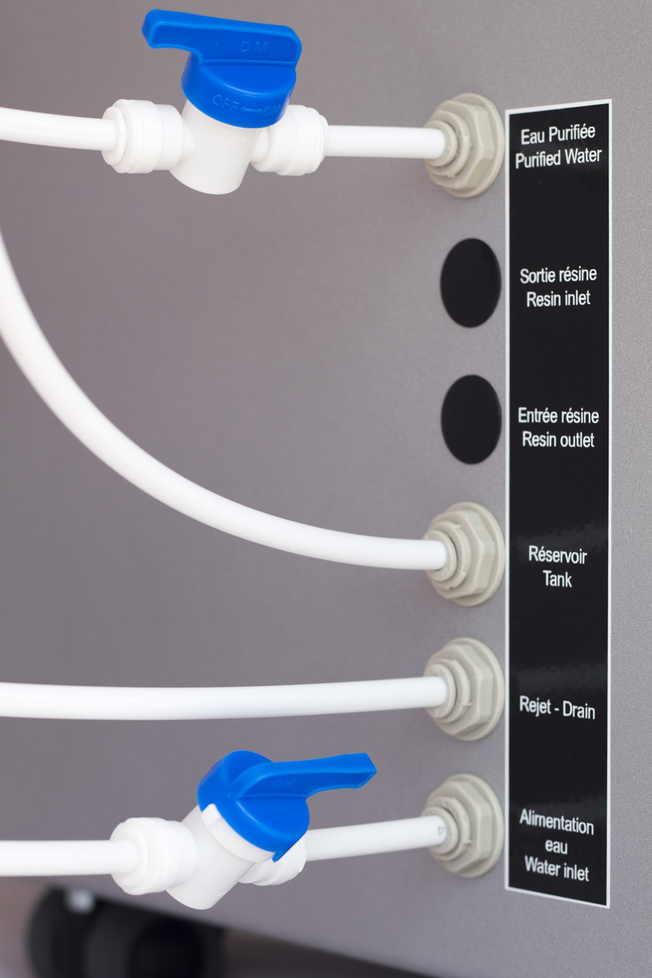
4.2 Connections
Purified water outlet to be connected via a tubing to an "isolation valve" allowing water to be drawn for the analyzer
To be connected to the storage tank
Drain of the osmosis unit to be connected directly to the sewer (to avoid to damage the system, must be always open ; do not connect a valve )
Connect to tape water inlet by using « male simple union » – Integrate an « isolation gate »

4.3 Installation of the reverse osmosis membrane

- Remove the membrane holder out of its two plastic stirrups . (Figure 1)

- Disconnect the water inlet pipe from the membrane holder by disconnecting the quick fit coupling. (Figure 2)

- Unscrew (by turning to the right) the high streaked part ("big cap") of the membrane holder.

- Once the membrane door is opened. Insert the new membrane (Figure 3), peripheral seal at the top, to the complete stop: the end of the collecting tube must be closed to the top of the membrane holder. (Figure 4)

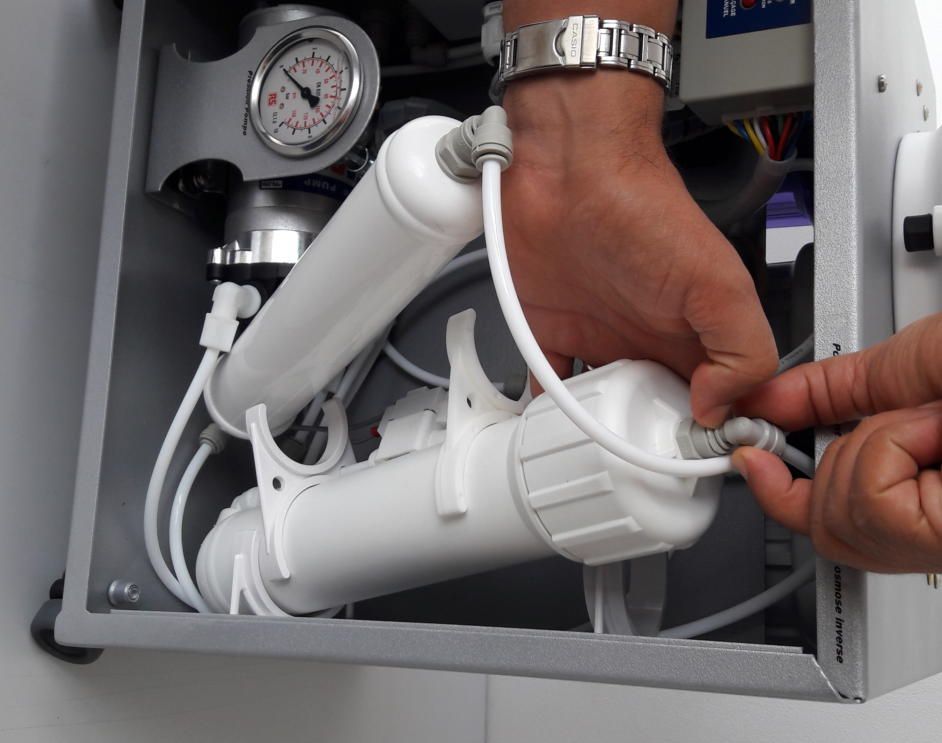
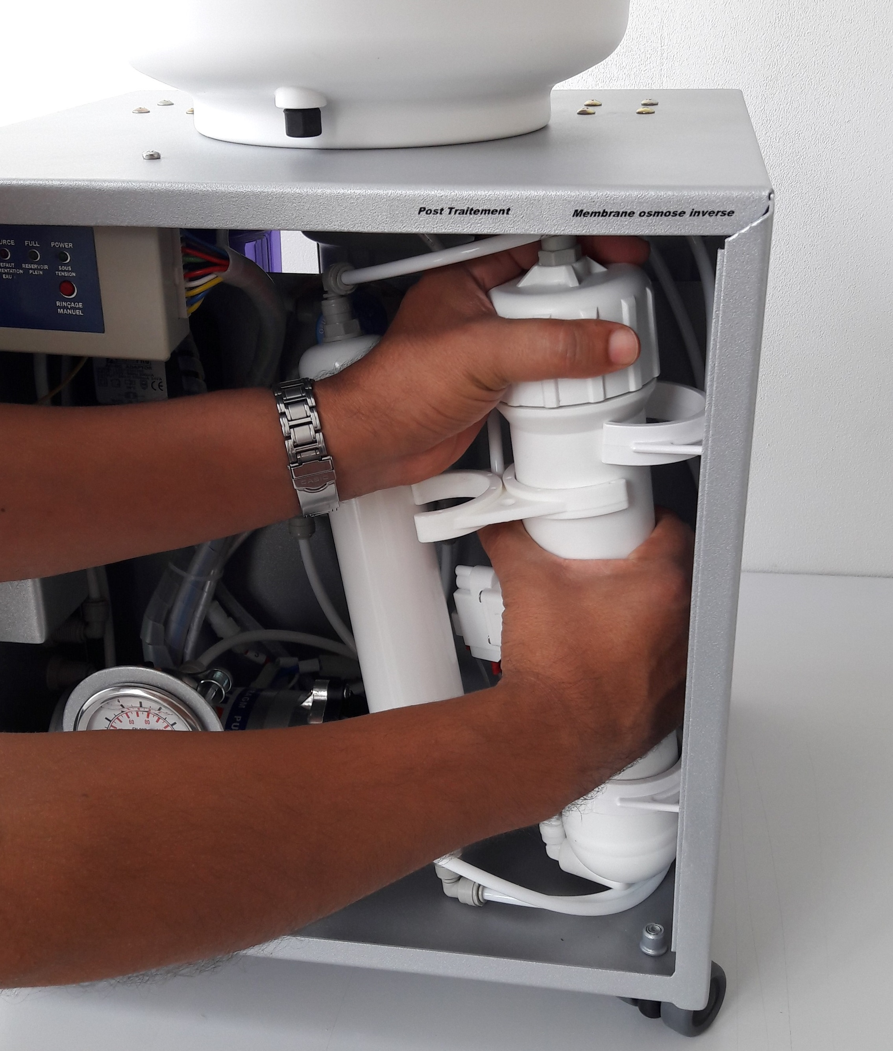

Figure 1 Figure 2

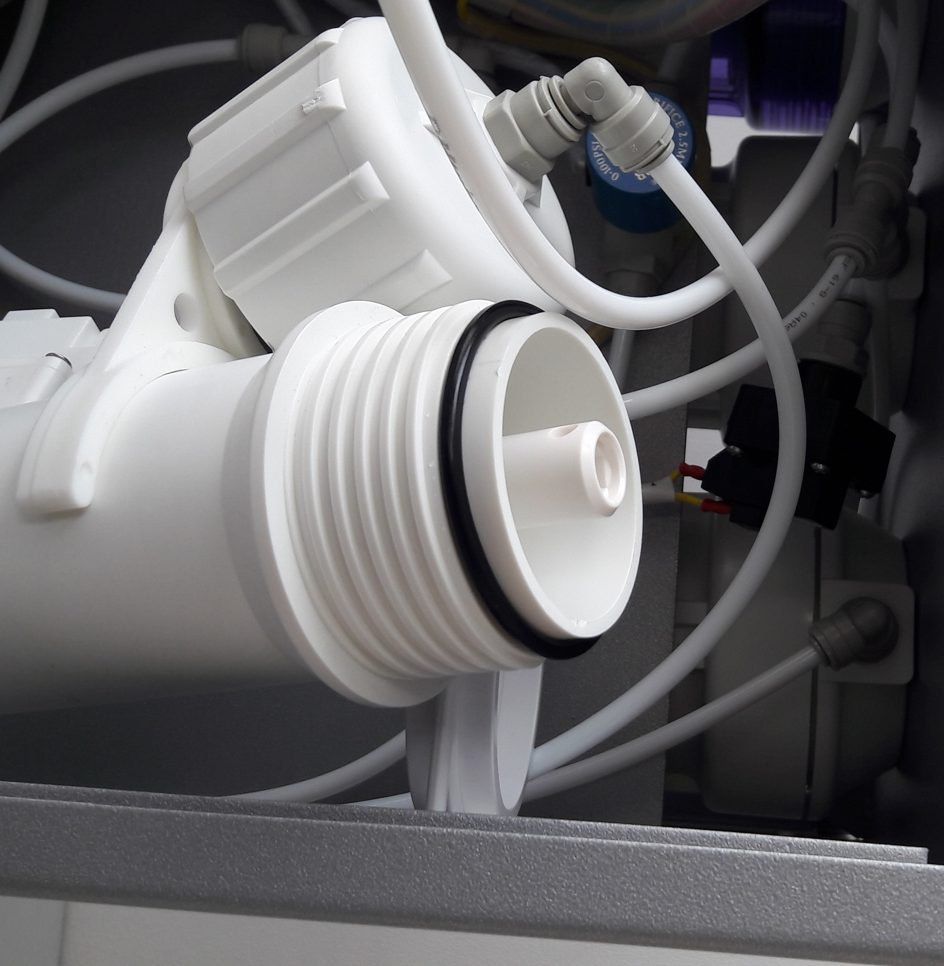
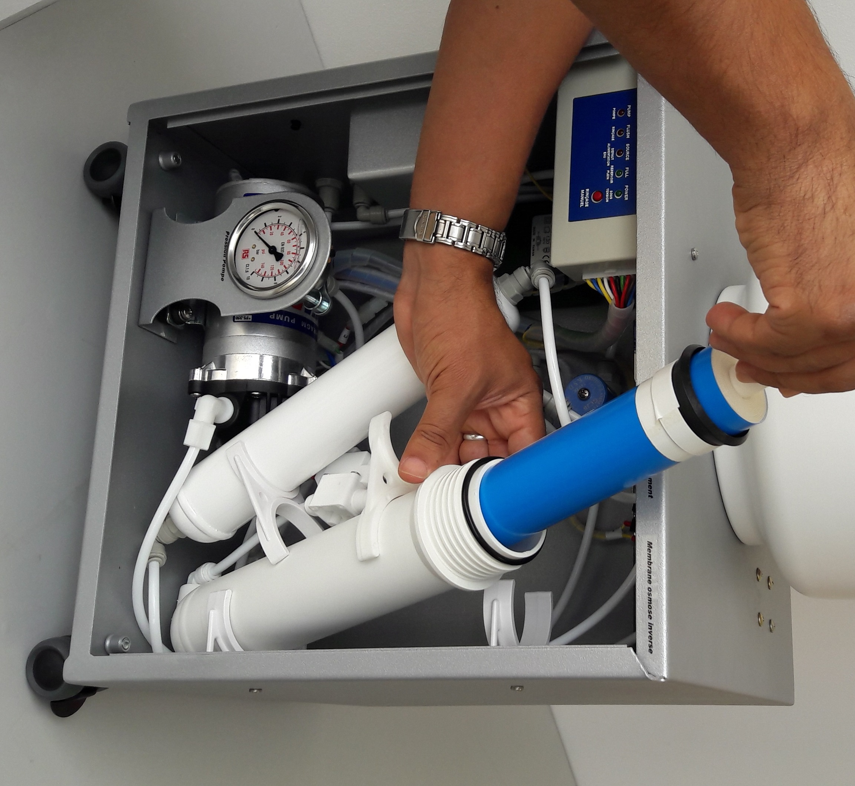

Figure 3 Figure 4

- Check that the O-ring is well-positioned at the bottom of the retaining wall of the membrane holder (see the drawing).

- Unscrew (by turning to the right) the high streaked part ("big cap") of the membrane holder.

- Clip the membrane on its stirrups.

5. System start up

- Connect the osmoser hydraulically then electrically.

- Check all hydraulic connectors.

- Close the storage tank valve.

- Open the purified water hand valve.

- Open the tap water inlet supply valve.

- Electrically switch on the osmosis unit.

The control unit goes through the following phases:

The power indicator indicates that the osmosis unit is energized.

The pump indicator indicates that the pump is running.

The flush indicator indicates that the system is in the rinse phase of membrane.
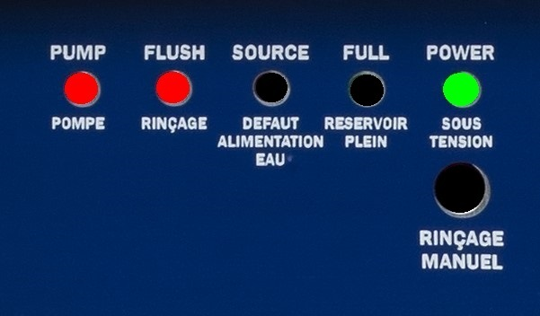
1 /

2/
The flush light goes off the system enters its production phase.

- Wait (a few minutes) for purified water to drain from the purified water tap, then let about 5 liters flow.

- Then carry out a conductivity measurement following the procedure described in the chapter "Conductivity measurement procedure" p.13. The value obtained must be 0 to 0.1 μS / cm. Then close the purified water hand valve.

- Open the storage tank valve and wait for its full refill: "Full" indicator lit in green

The control unit goes through the following phase:

The osmosis unit is then operational

6. Maintenance and service
6.1 Flow measurement procedure

I General points

The flow measurement is interesting to check the filters and reverse osmosis membrane plugging state.
This measurement is interesting only if it is compared to a water temperature value.
The osmosis membrane flow is function of the supply water temperature.
We generally allow a flow drop of 3 % per Celsius degree in a range from 10 to 25 °C.

This flow measurement must be compared to the osmoser theoretical nominal value with a fixed temperature, which is 25 °C:
Purified water flow at 25 °C ≈ 15 liters / hour
Note: this theoretical flow rate represents the production at a "tank outlet" pressure of zero bar; it decreases according to the increase in the pressure "Outlet tank".

II Equipment

 A graduated test tube of 500 mL.
 Un chronometer.

III Operating method

❶ Close the storage tank valve.
❷ Open the purified water outlet hand valve ; let flowing 30 seconds to get a stabilized flow.
❸ Trigger the chronometer as soon as the test tube is filling. Make a measurement on 1 or 2 minutes.
❹ Convert the result into liters/hour. Compare this measurement to the theoretical value.

6.2 Conductivity measurement procedure

I General points

The global quantity of dissolved solids in water can be measured by the CONDUCTIVITY.
The conductivity measurement allows estimating the demineralization quality.
The conductivity, resistivity opposite, is expressed in microsiemens per centimeter (µS / cm).

The relation between the TDS (total dissolved solids = total mineralization) and the conductivity is:

1 µS / cm ≈ 0, 4 mg / L of NaCl (sodium chloride)

II Equipment

 The conductivity is measured with a conductimeter (range of measurement from 0,1 to 99,9 µS / cm).

III Operating method

1/ Purified water conductivity measurement « osmoser exit »

This conductivity measurement must be doing way weekly at the purified water taking bench tap level following the operating method described in the frame IV.

2/ Conductivity measurement reverse osmosis « membrane exit »

This conductivity measurement is realized in corrective way (for diagnostic) at the beginning of the storage tank connecting pipe level.

❶ Close the storage tank hand valve.
❷ Close the tape water inlet hand valve.
❸ Disconnect the storage tank connecting pipe at the osmoser level.
❹ Connect instead of the pipe equipped with its hand valve in closed position (provided with the system) which will permit to realize the conductivity measurement.
 Open the tape water inlet valve.

Then the conductivity measurement can be realized following the operating method described in the frame IV.

Once the measurement realized:

 Close the tape water inlet valve.
 Disconnect the pipe equipped with its hand valve then reconnect the storage tank connecting pipe at the osmoser level.
 Open the storage tank hand valve.
 Open the tape water inlet hand valve. The osmoser is again operational.

IV Conductivity measurement operating method

❶ Let flowing the water to test 15 to 30 seconds.
❷ Remove the conductivity meter protection cap.
❸ Rince the protection cap and the conductivity meter probe with the water to test.
❹ Renew the operation 2 to 3 times.
❺ Switch on the instrument.
❺ Fill to the brim the protection cap with the water to test then plunge the conductivity meter: the put up value corresponds to the conductivity expressed in µS / cm.
❻ Renew the operation 2 to 3 times; the retained value will be the last measurement one.
❼ Switch off the conductivity meter then put back the protection cap.

PURIFIED WATER CONDUCTIVITY VALUE INTERPRETATION

Conductivity < 5 µS/cm : Very good water quality; no effect on the analysis quality.

5 µS/cm < Conductivity < 8 µS/cm : Plan the ion exchange resin cartridge replacement.

Conductivity > 8 µS/cm : Change the ion exchange resin cartridge.

V Conductivity meter calibration

The conductivity is function of the water temperature. The conductivity corrects automatically the measurement in function of the temperature. For doing this, a calibration of your instrument is realized in our workshop before the delivery. Nevertheless, to keep your results accuracy, we deeply recommend proceeding to a calibration at least 1 time a year.

The calibration procedure, which is simple and fast, is reminded here after.

❶ In a container, overturn the calibration solution « 84 µS / cm » (available with our after sales service with the reference 950025) up to obtain a level of 7 to 8 cm.

❷ Plunge the conductivity meter in the container with the solution respecting the maximum immersion level (« max level »).

❸ Wait the reading stabilization, and then with the small yellow screwdriver, turn the potentiometer accessible on the instrument right side up to the adjustment to the nominal value of 84 µS / cm.

Then the calibration is finished.

Note: The calibration solution 500 mL bottle permits to realize several calibrations.

